EXPERIMENT 7 — USER PROFILES & ACTIVITY LOGGING SERVICE
Student Step-by-Step Implementation Guide

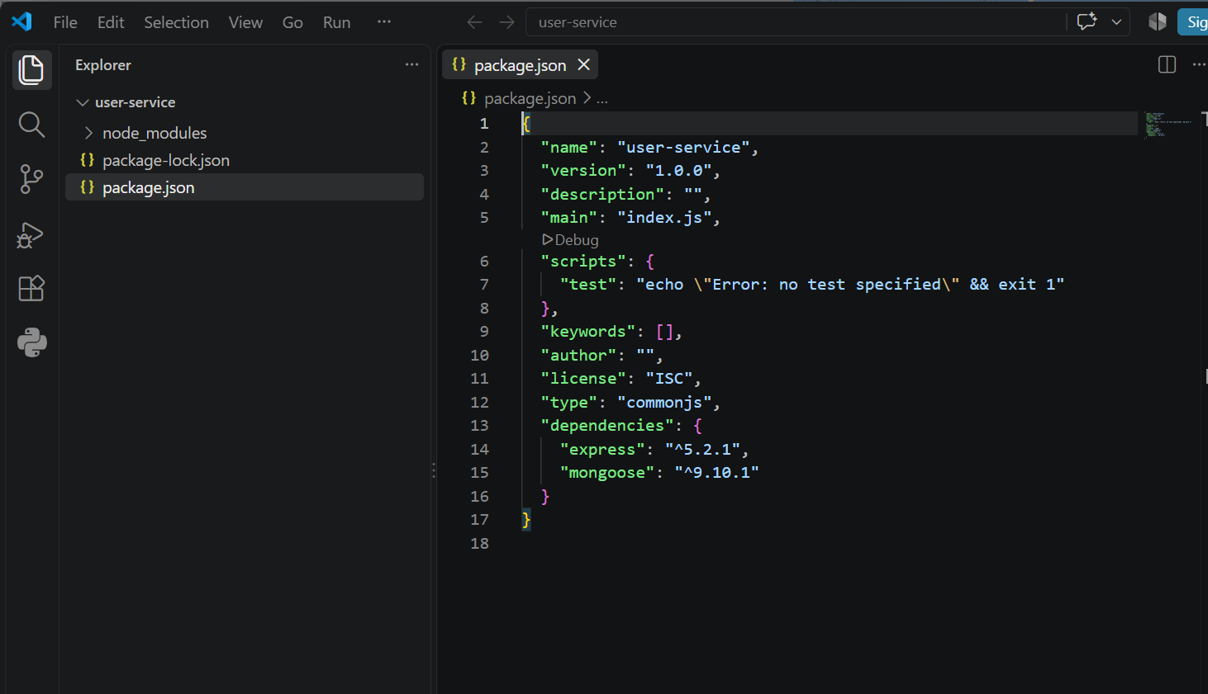

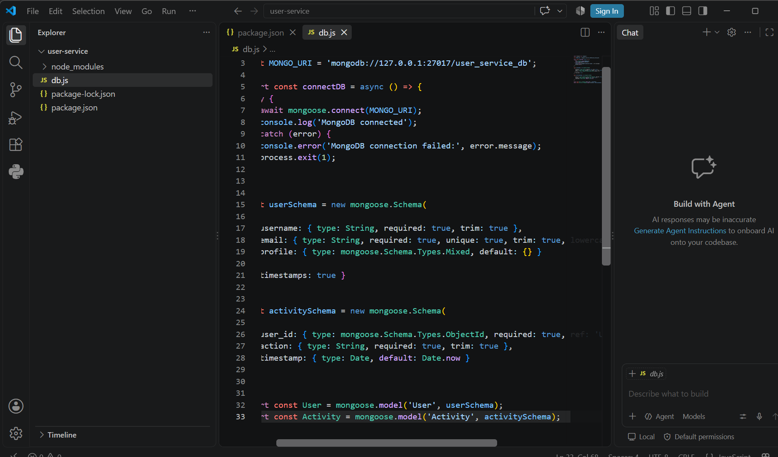

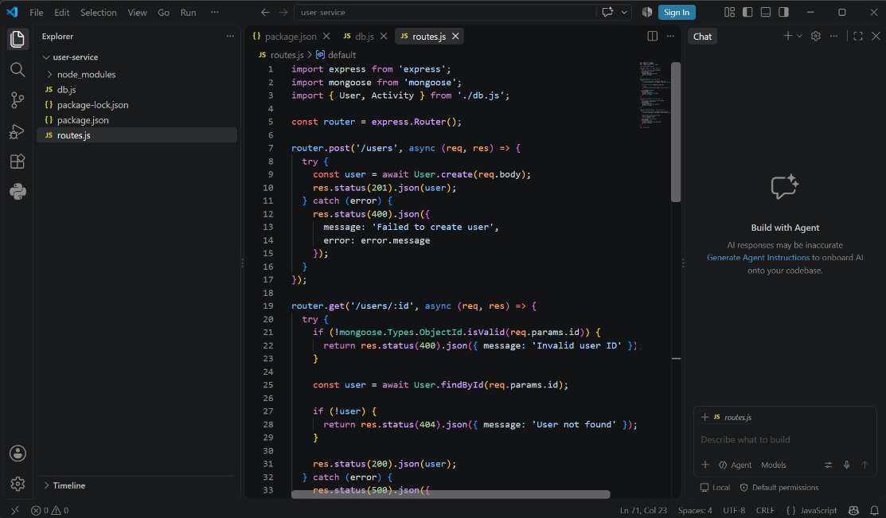
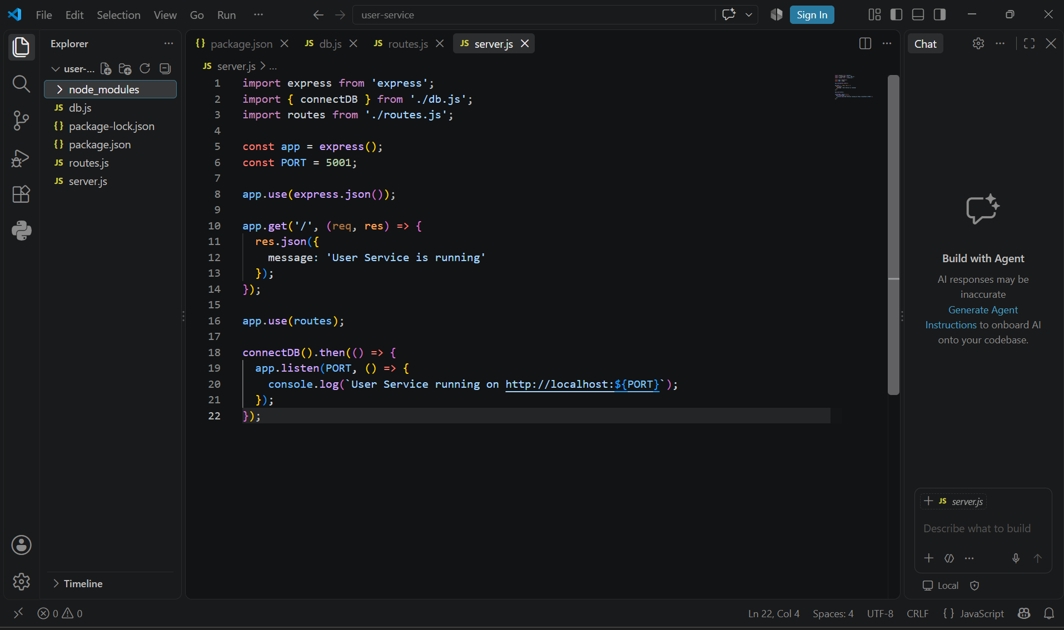
Start Your Node.js Server
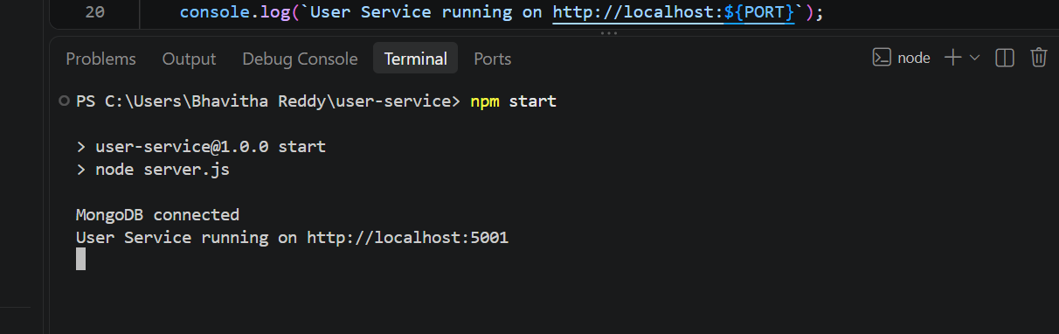
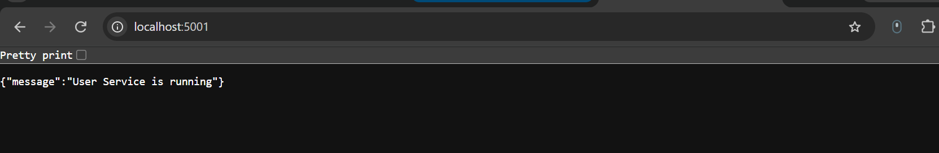
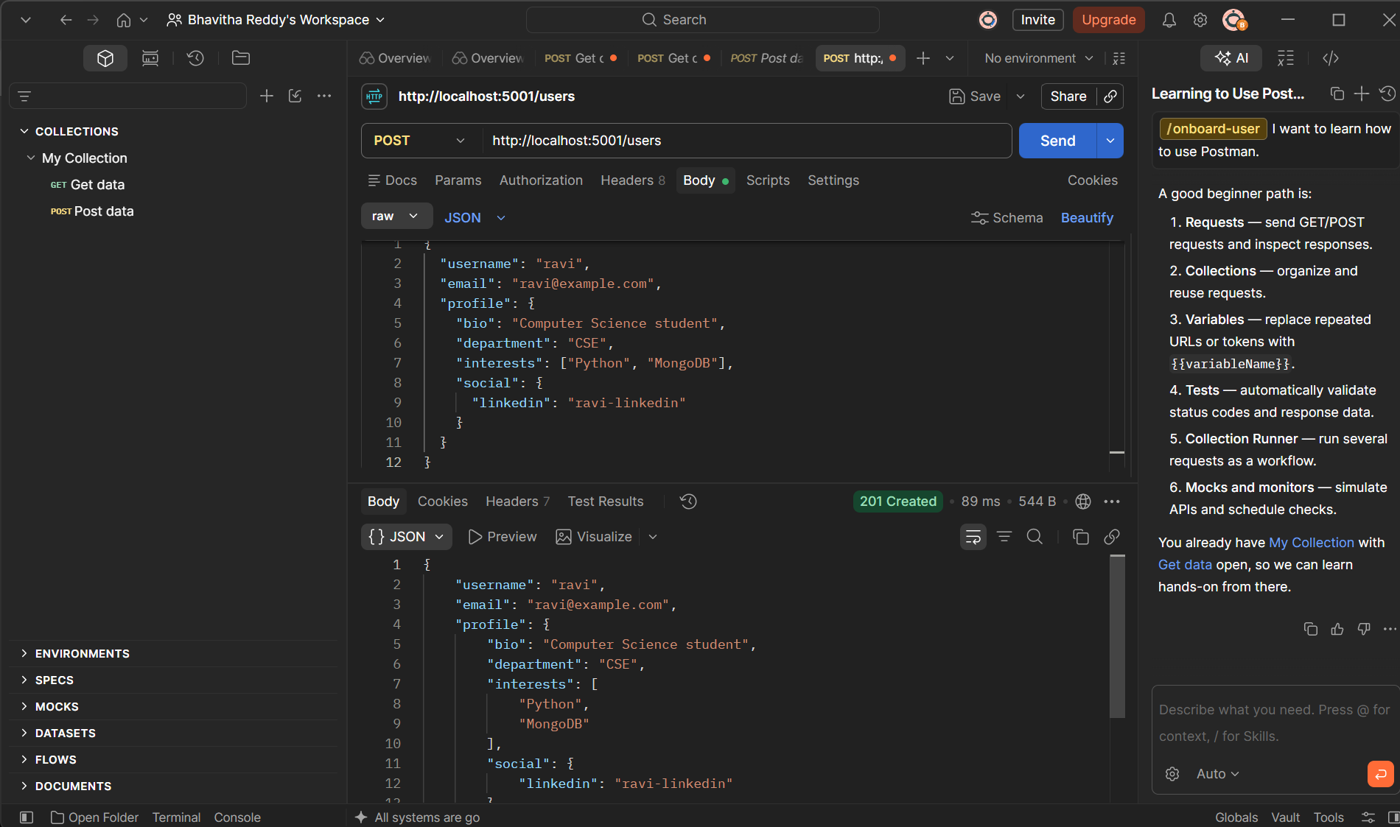
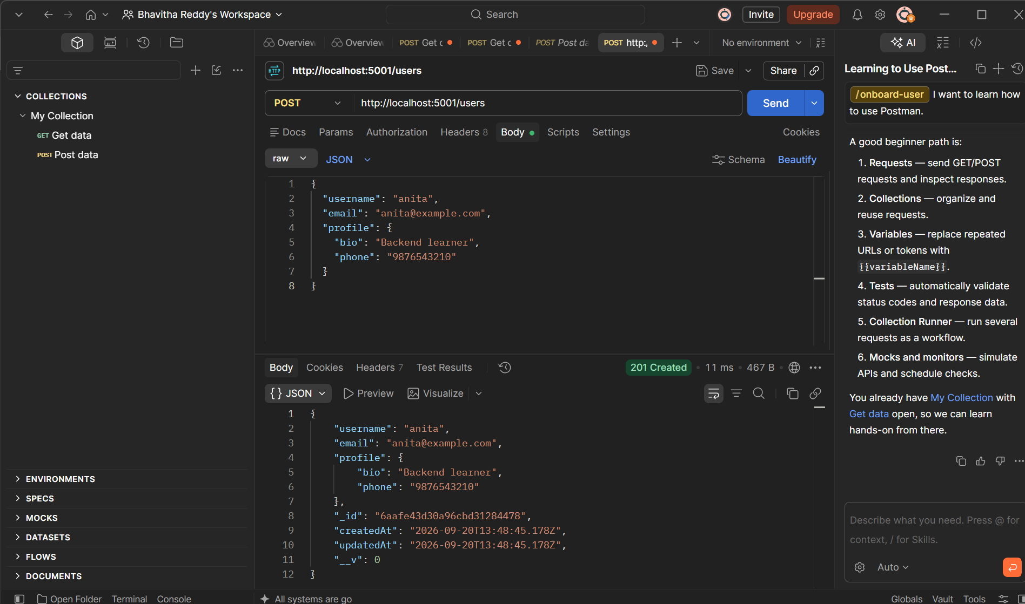
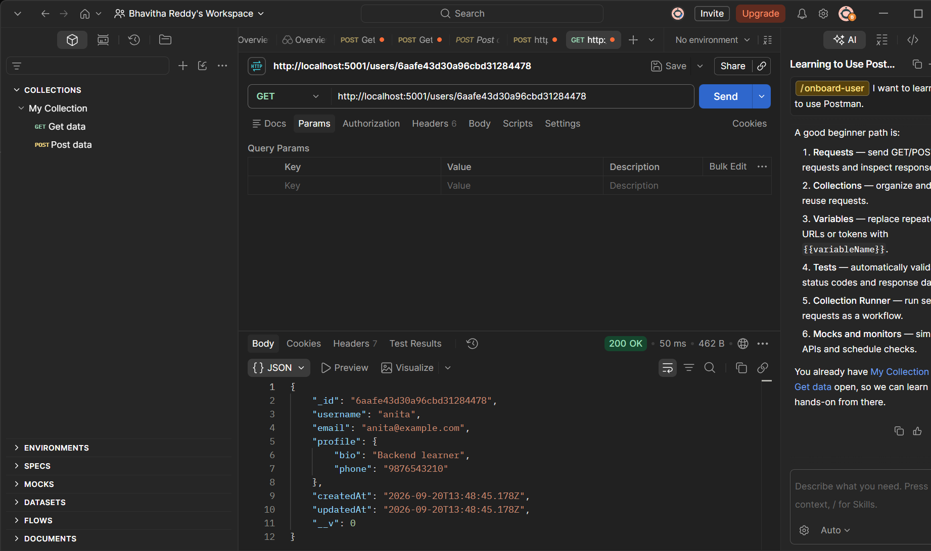
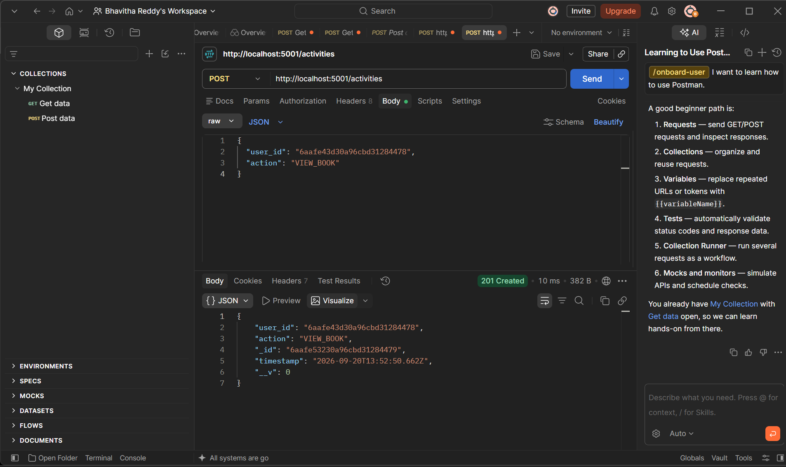
Create SEARCH_BOOK
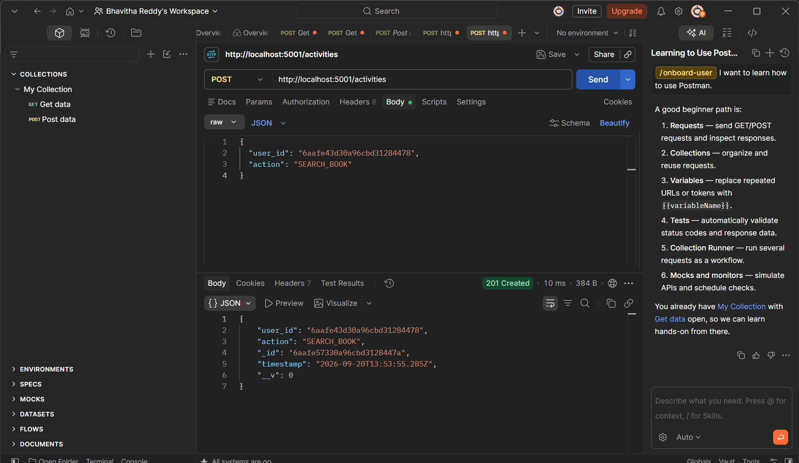
Create LOGIN
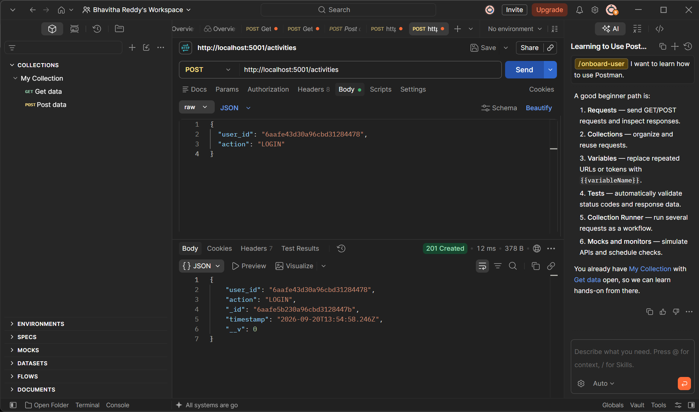
Create BORROW_BOOK
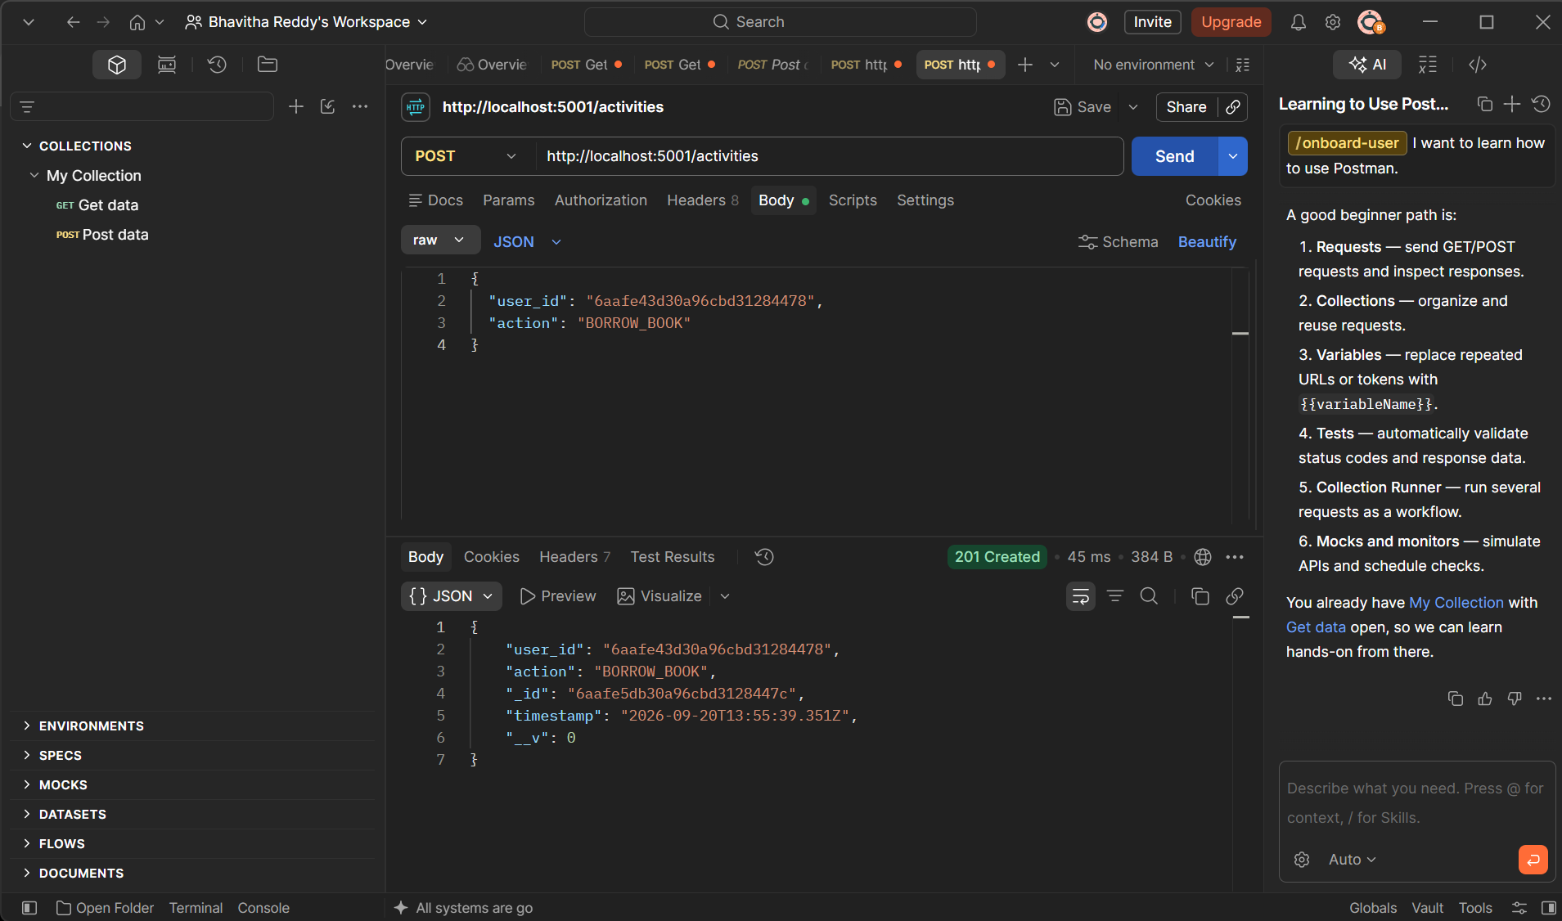
Test GET /activities/:user_id
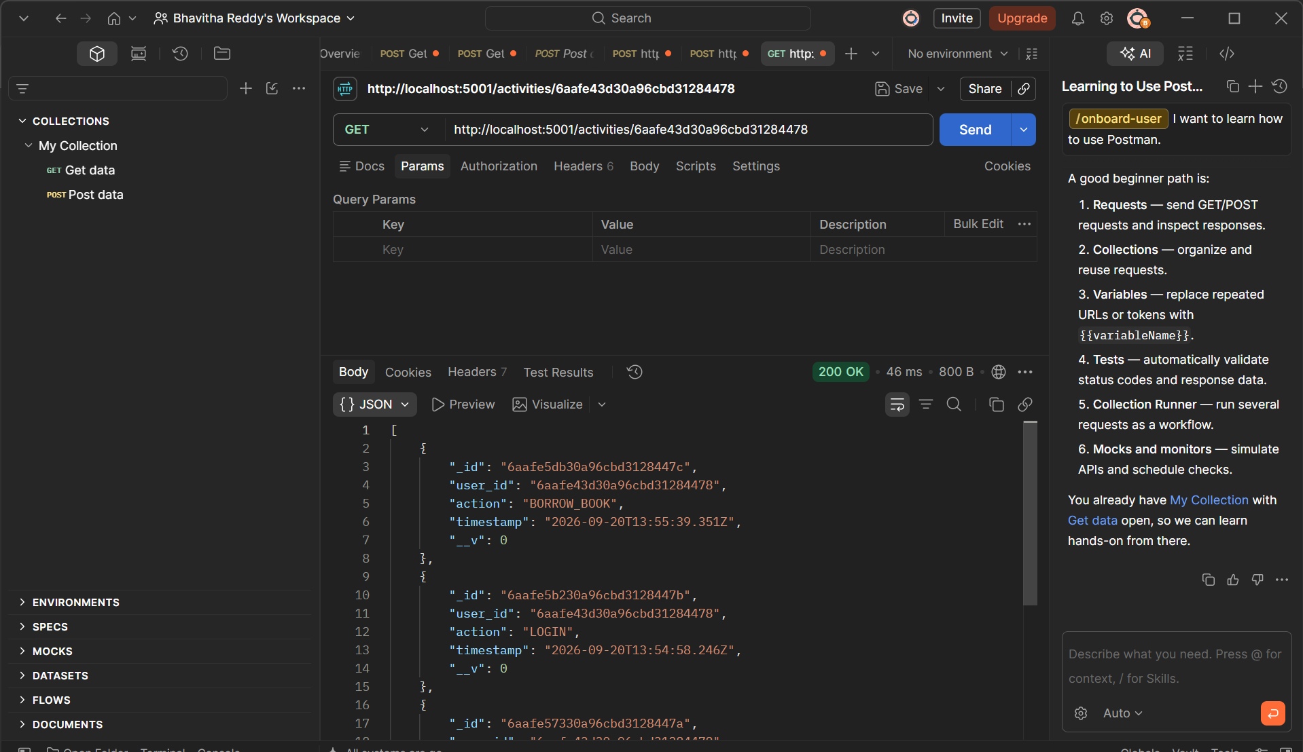

Mogosh compress

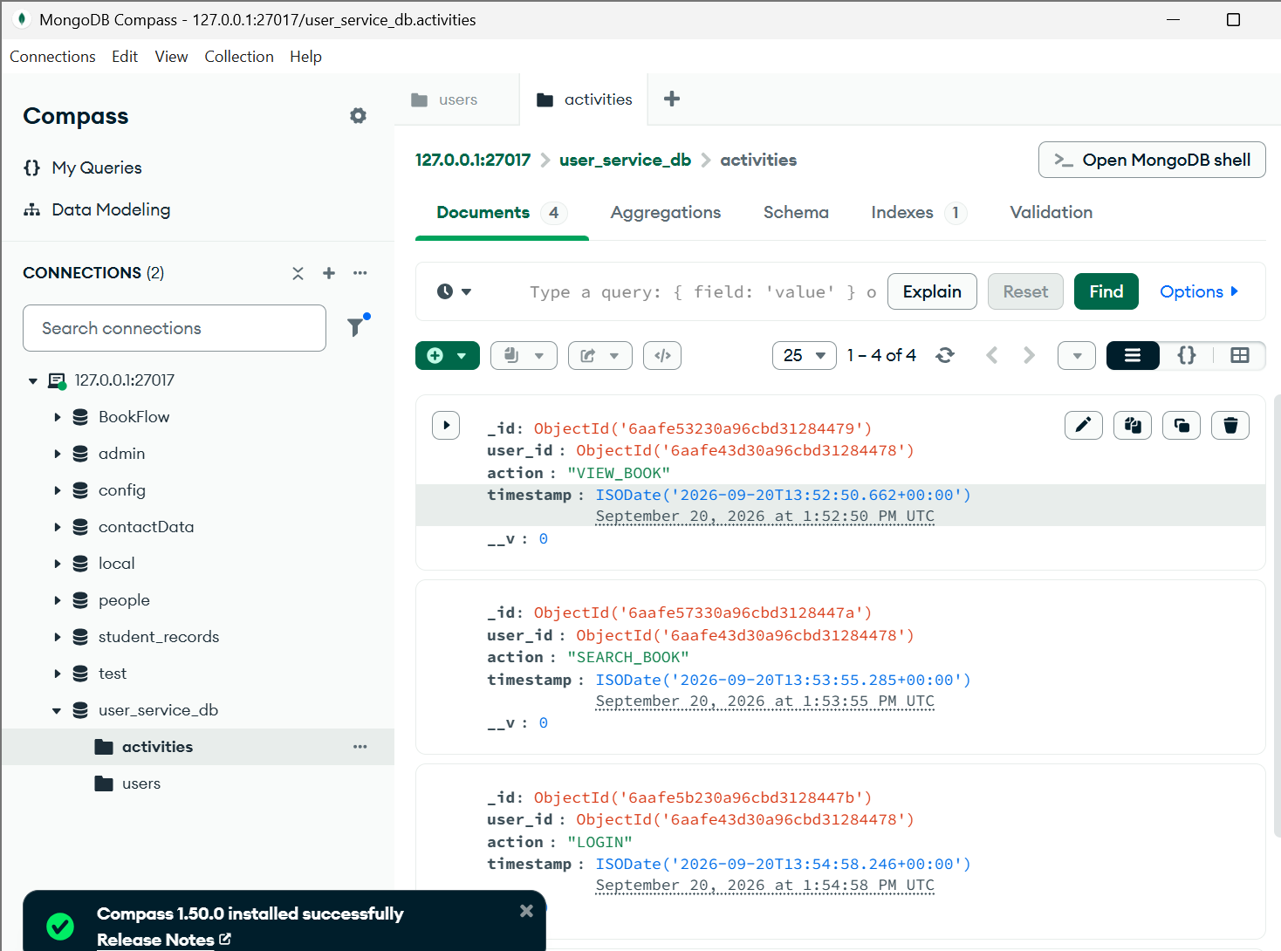
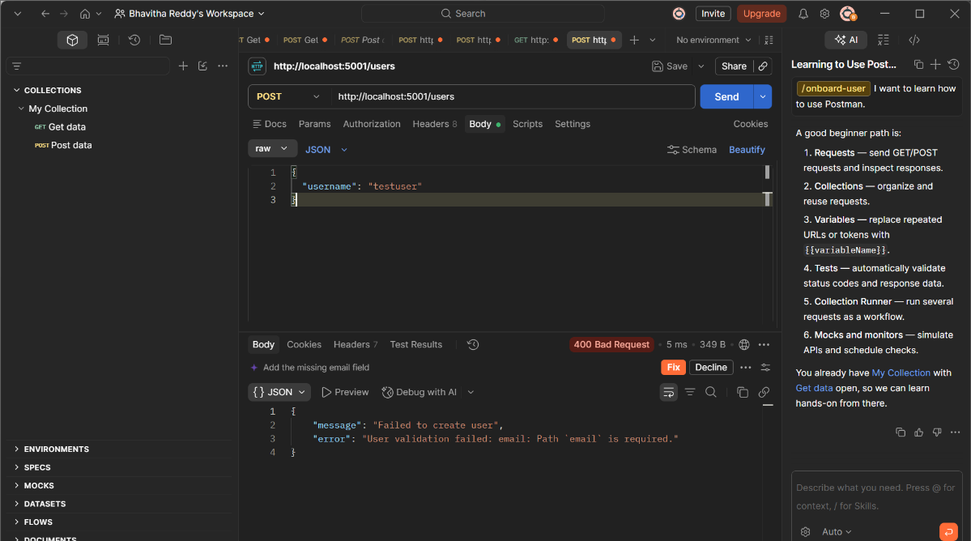
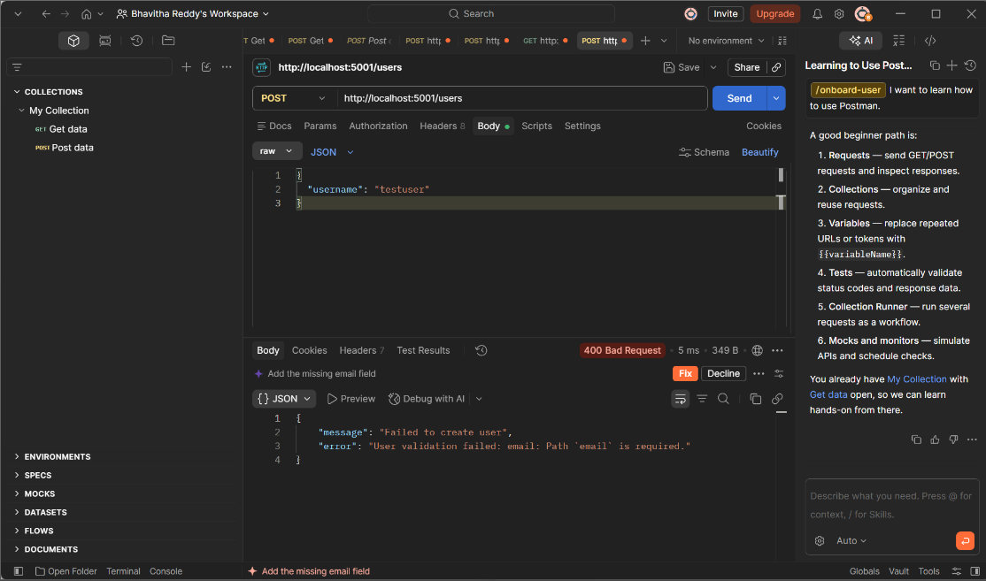

Test Missing Email

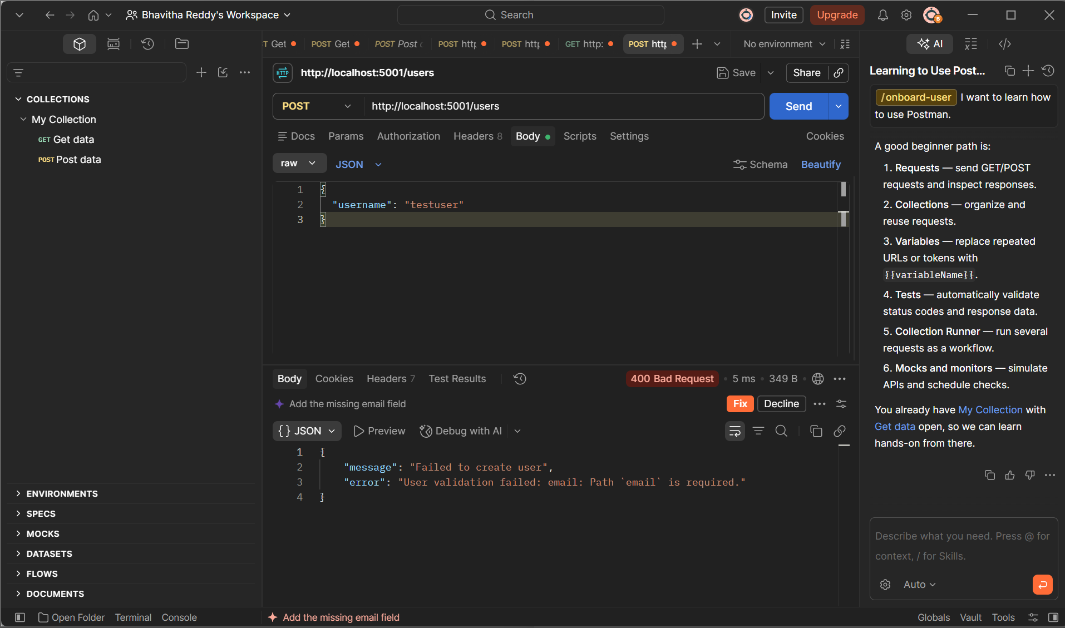
Test Non-Existing User
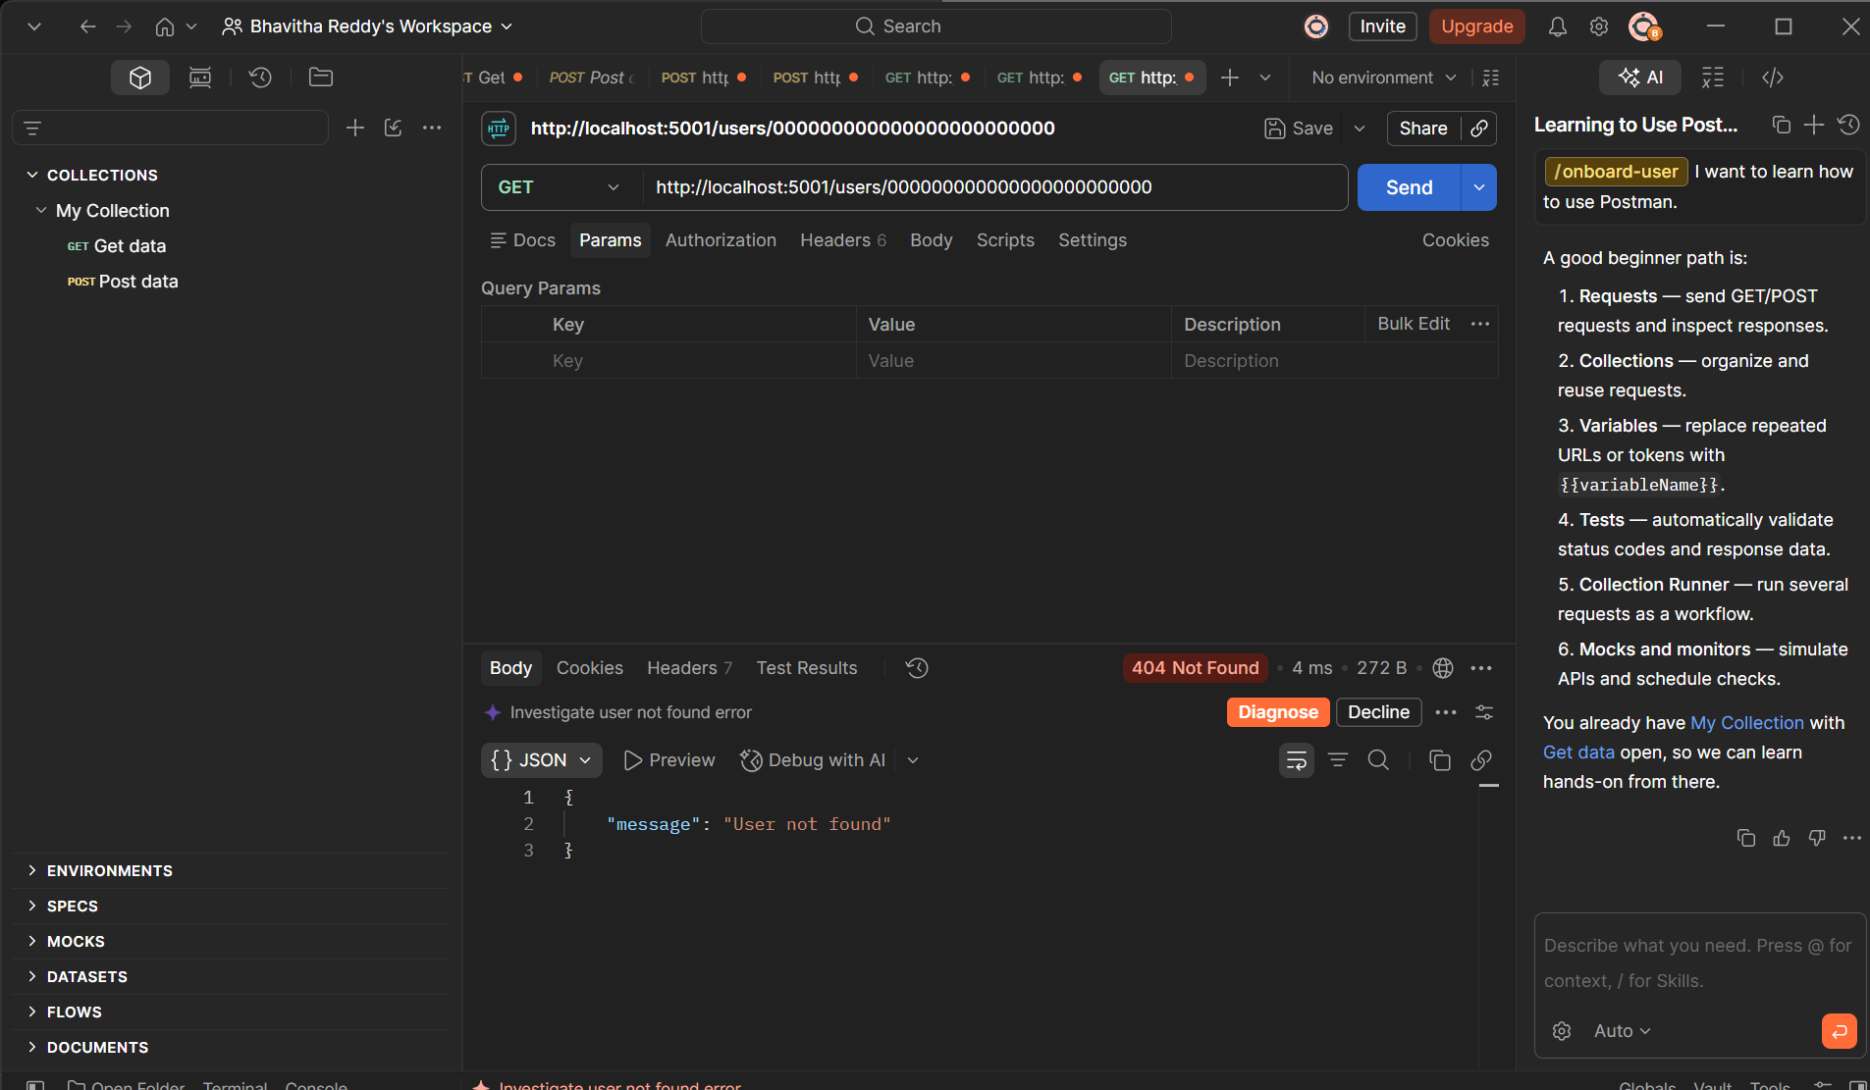

Conclusion: The User Profiles & Activity Logging Service was successfully implemented using Node.js, Express.js, MongoDB, and Mongoose. The service supports creating and retrieving user profiles and activity logs through REST API endpoints. MongoDB provides flexible document structures for user profiles, while Mongoose manages database schemas and operations. The service runs independently from the FastAPI BookFlow service.

